Artificial Intelligence – Lab Assignment 1
AI Agent: Smart Travel Planner Agent
Student: Rayan Ahmed
Repository: Rayan_lab1

AI Agent Name
Smart Travel Planner Agent
Component | Description
Agent | Smart Travel Planner Agent
Environment | Travel planning environment: destinations, hotels, transport, weather, prices and user preferences
Sensors | User destination, budget, dates, preferred activities, weather information and travel prices
The Smart Travel Planner Agent is an AI agent that helps a user plan a trip. It takes information such as destination, budget, travel dates, weather and preferred activities, then produces a suitable travel recommendation or itinerary.

Graphical Representation
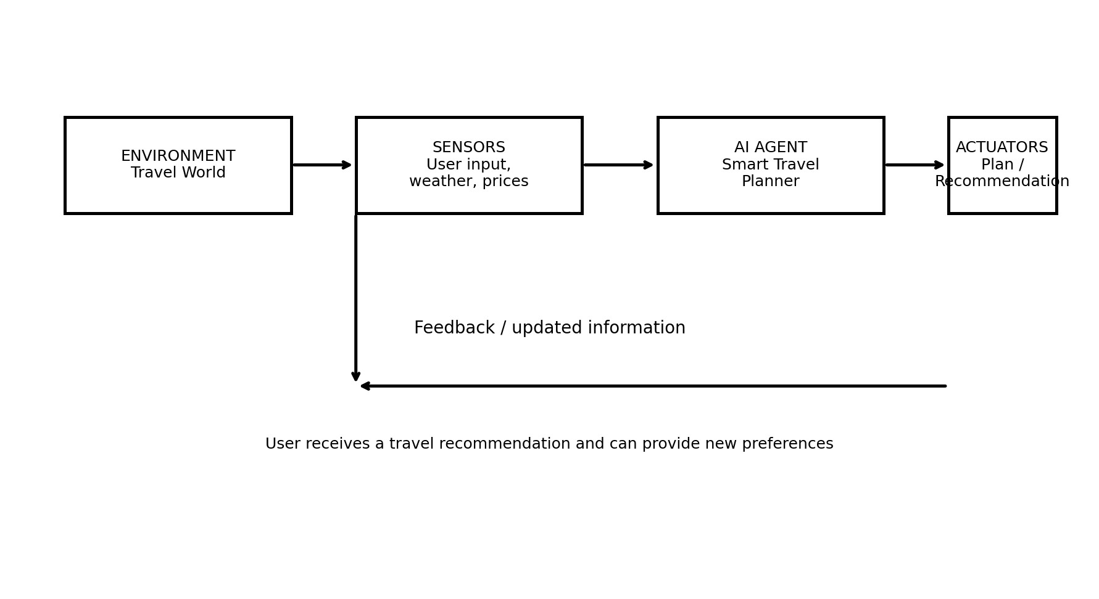
The agent receives information from the travel environment through sensors, processes it, and uses actuators to provide a travel plan or recommendation. The user can provide new information, creating a feedback loop.

Agent Formulation
Actuators | Displays destination suggestions, itinerary, estimated cost and travel recommendations
Goal | Create a useful, affordable and suitable travel plan for the user

Environment Types
Property | Type | Reason
Observability | Partially Observable | The agent does not know every possible travel condition or hidden user preference.
Agents | Single Agent | The planner itself is the main decision-making agent.
Determinism | Stochastic | Weather, prices and availability can change unexpectedly.
Episodic / Sequential | Sequential | The current planning decision can affect later parts of the trip.
Static / Dynamic | Dynamic | Travel prices, weather and availability may change over time.
Discrete / Continuous | Mixed | Choices such as destinations are discrete, while time, distance and budget are continuous
Known / Unknown | Partially Known | The agent knows some travel rules/data but may not know future conditions.

PEAS Framework Evaluation
PEAS Element | Evaluation
Performance Measure | User satisfaction, suitable destination, affordable cost, reasonable travel time, useful itinerary and safe/c
Environment | Destinations, hotels, transport options, weather, prices, activities and user travel requirements.
Actuators | Show recommendations, itinerary, estimated cost, activity suggestions and warnings.
Sensors | Read user preferences and travel information such as destination, budget, dates, weather and prices.
Conclusion
The Smart Travel Planner Agent is a simple example of an intelligent agent. It senses travel-related information, evaluates possible choices, and acts by giving the user a suitable travel plan. Its PEAS framework clearly defines how its performance, environment, actuators and sensors can be evaluated.

